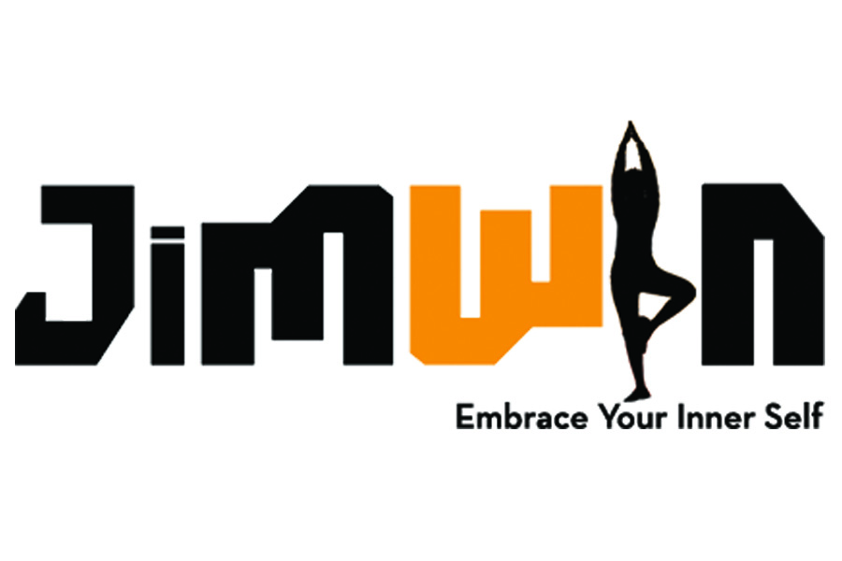

Registration/Policy Information & Waiver Form

Name: ___________________________________________________________________

Address: _________________________________________________________________

Postal Code:_____________________________________________________________

Phone: ________________________ Email: ___________________________________

Emergency Contact (Name/Phone): __________________________________________

Have you taken Yoga before? Yes ( ) No ( )

Do you participate in any other physical activities?
_________________________________________________________________

All information is strictly confidential.

Please check any medical/physical conditions shown below, if applicable, please.

High/Low Blood Pressure ( ) Pregnancy ( ) Dizziness ( )
Wrist Problems ( ) Arm/Shoulder Injuries ( ) Knee Injuries ( )
Neck Issues ( ) Back Problems ( ) Heart Problems ( )
Diabetes ( ) Anxiety Disorders ( ) Joint Replacement ( )
Depression ( ) Recent Surgery ( ) Other ( )

If checked, please explain
__________________________________________________________________

__________________________________________________________________

Cancellation & Payment Policy

- All class packages have an expiration date and are non-refundable or transferable.
- We will not give refunds for classes taken or partially taken.
- Private Sessions must be cancelled 24 hours in advance or student will be charged the full rate of the session.
- Credit Cards, Checks and cash are accepted as payment.

AGREEMENT OF RELEASE AND WAIVER OF LIABILITY FROM

I, ____________________________________, herby agree to the following

- That I am participating in the Yoga Class/Workshop, offered by Maraike Harten/JimWin Yoga, during I will receive information and instructions about yoga and health. I recognize that yoga may require some physical exertion, which may be strenuous and may cause physical injury, and I am fully aware of the risks and hazards involved.

- I understand that it is my responsibility to consult with a physician prior to and regarding my participation in the Yoga Class or Workshop. I represent and warrant that I am physically fit and I have no medical condition which would prevent my full participation in the Yoga Class/Workshop.

- In consideration of being permitted to participate in the Yoga Class or Workshop, I agree to assume full responsibility for any risks, injuries or damages, known or unknown, which I might incur as a result of participating in the program.

- In further consideration of being permitted to participate in the Yoga Class/Workshop, I knowingly, voluntarily and expressly waive any claim I may have against Maraike Harten/JimWin Yoga and class/workshop Sponsor, for any injury or damages that I may sustain as a results of participating in the program.

- I, my heirs or legal representatives, forever release, waive, discharge and covenant negligence or other acts.

I have read the above release and waiver of liability and fully understand its contents as well as the Refund/Cancellation Policies. I voluntarily agree to the terms and conditions stated above.

REGISTRANT’S SIGNATURE: _________________________________________

Print Name: ______________________________________________________

DATE: ____________________________

If registrant is under 18 a legal guardian’s authorization is required:

AS LEGAL GUARDIAN OF
I CONSENT TO THE ABOVE TERMS AND CONDITIONS

GUARDIAN’S SIGNATURE: ___________________________________________

Print Name: _______________________________________________________

